
Land Information Ontario (LIO) Warehouse
Data Class Name: Wildlife Values Area
Documentation
Produced by: Spatial Data Support Unit
Ministry of Natural Resources and Forestry
Date: November 9, 2021

Purpose

This document provides additional information to support the use of geospatial data. The Physical Model Diagram provides a visual representation of the relationships in the data class. The Data Change History lists all the modelling and access changes that have occurred during the lifecycle of the data class. A data description identifying table and field names is available upon request.

Need Assistance?
Please contact LIO Support at lio@ontario.ca or 705-755-1878 if you require help.

Physical Model Diagram
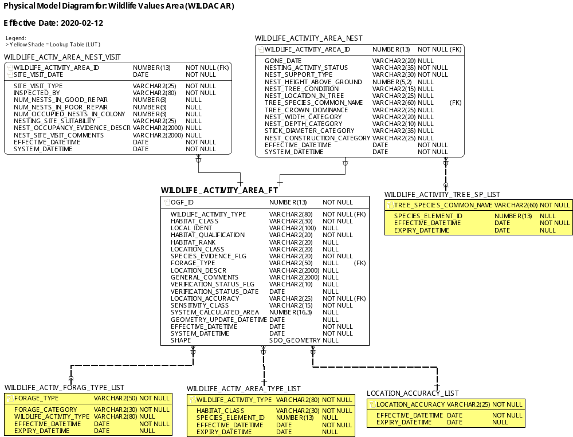
Data Class Change History
Data Class Name: Wildlife Values Area
Data Class Short Name: WILDACAR
Date  YYYY-MM-DD | Details of Change
2021-11-09 | 2 new Lookup Table subtype values added to: WILDLIFE_ACTIV_AREA_TYPE_LIST  - Eastern Wood-pewee Breeding Area  - Wood Thrush Breeding Ar
2021-08-26 | Lookup table updates in WILDLIFE_ACTIV_AREA_TYPE_LIST. Apostrophes removed from values due to reoccurrence of LIO Editor bug. The following subtype names have been updated:  - Blanding’s Turtle Aquatic and Associated Habitats  - Blanding’s Turtle Hibernacula  - Blanding’s Turtle Nesting Area  - Bonaparte’s Gull Nesting Site/Colony  - Forster’s Tern Nesting Site/Colony  - Kirtland’s Warbler Breeding Area
2021-01-18 | Lookup table updates in WILDLIFE_ACTIV_AREA_TYPE_LIST. Apostrophes re-inserted into values (were removed during initial implementation due to LIO Editor bug when selecting subtypes). The following subtype names have been updated:  - Blanding’s Turtle Aquatic and Associated Habitats  - Blanding’s Turtle Hibernacula  - Blanding’s Turtle Nesting Area  - Bonaparte’s Gull Nesting Site/Colony  - Forster’s Tern Nesting Site/Colony  - Kirtland’s Warbler Breeding Area
2021-01-12 | Lookup Table subtype updates: WILDLIFE_ACTIV_AREA_TYPE_LIST  - Eastern Wolf Nursery Area record expired  - New record: 'S1,S2,S3 Ranked Plant Species' (Medium Sensitivity by default)
2020-02-12 | NEW data class created to consolidate and manage data from the following legacy NRVIS data classes:  - Aquatic Feeding Area (AQUAFEED)  - Breeding Area (BREEDARE)  - Calving Fawning Site (CALVFAWN)  - Feeding Area, Wildlife (FEEDAWLD)  - Mast Producing Area (MASTPROD)  - Nesting Site (NESTING) colony bird species only*  - Nursery Area, Wildlife (NURSAWLD)  - Resting Area (RESTAREA)  - Staging Area, Wildlife (STAGAWLD)  - Travel Corridor, Wildlife (TRAVCWLD)  - Wintering Area (WINTERNG)  * non-colony bird species nesting sites are stored in the Wildlife Values Site (WILDACSI) layer.
Data Description
Please refer to the metadata record for the data description.

